Portable pump suction EX gas detector
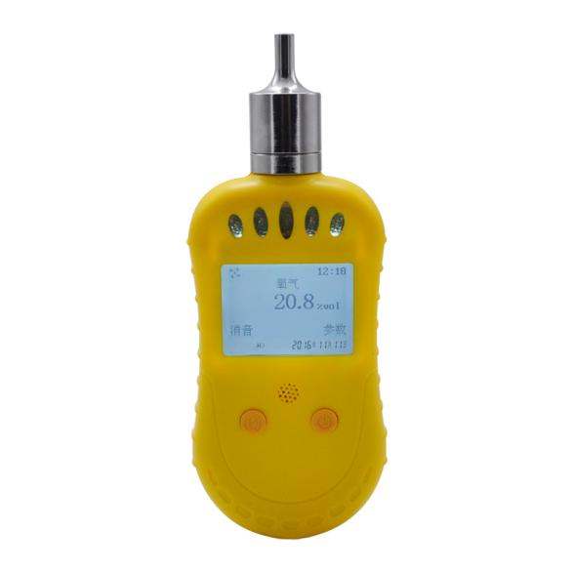
Portable single gas detector, it is a kind of concentration of instrument that can continuous detect the concentration of oxygen, toxic and harmful gas in the working environment. The detector detects gas concentration with natural diffusion mode, which uses the imported sensors and has a good sensitivity and repeatability.
Basic parameters:
Size: 180mm * 71mm * 51mm
Weight: 160 g
Sensor types: pump type(gas catalytic combustion type, special separately)
Destination gas: oxygen (O2), gas (EX), poisonous and harmful gases (CO, H2S, NH3, CL2, etc.)
Response time: oxygen <30S, carbon monoxide<40s, can be gas <20s；
Time display: the machine is year, month, day, and the clock display function
Display : dot matrix liquid crystal display in English, high brightness white backlight
Alarm: voice alarm More than 90 dbvoice alarm (10 cmaway from instrument) light alarmRed LED
Work mode: continuous work, full of electricity in the case of four standard set of 15 hours (off pump), other gas 7 days or so, the above is for reference only the standby time depending on the number of alarm)
Temperature range: - 20 ℃ to 50 ℃
Humidity: 15% ~ 95% RH (No condensation)
Power supply: the lithium battery power supply (1500 mah)
Charging time: 3 ~ 5 hours
Charging voltage: DC5V (dc)
Package included:
1. Portable pump suction EX gas detector
2. User Manual

